The inverse square law nature of Gravitation

CSAFE008

KEYPOINTS

CHKSY002

Gravitation (‘gravity) is an attractive force that acts between all objects that have mass.

CHKSY002

The further the objects are apart, the weaker the force of gravity.

CHKSY002

The force of gravity obeys an important concept found in many areas of Science - an inverse square law. The intensity of light from point objects such as stars also follows this law.

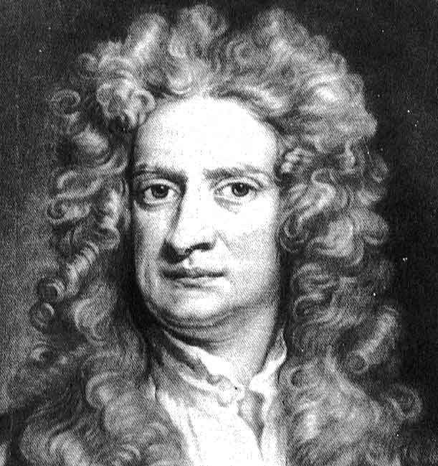

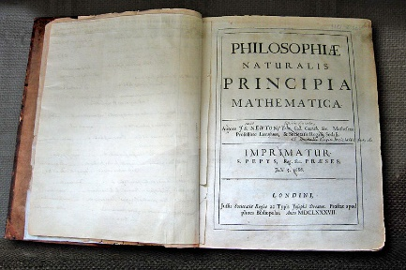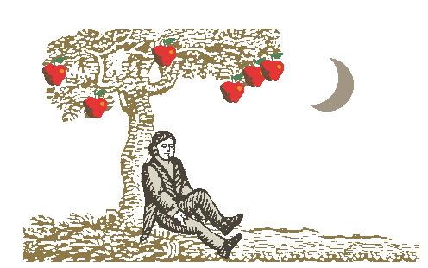

In 1687, Isaac Newton (above) published his universal Law of Gravitation that concerns the mutual force of gravity acting on two (massive) objects. The law states that the magnitude of this force is directly proportional to the product of the masses of the two objects, and inversely proportional to the square of their distance apart.

This can be written as an equation:

***F* = *G* *M*1 *M*2**

***r*2**

where *M*1 and *M*2 are the masses of the two objects and *d* is the distance between them (strictly their centres). *G* is the gravitation constant with the vale 6.67 x 10-11 N m2 kg-2.

**Use of this formula will NOT be tested at GCSE level.** However, AS/A-level Physics students can look forward to meeting this relationship at some time in their studies!

This important type of relation between force and distance is called an **inverse square law** since if the distance between the two objects doubles (*increases* by 2), the force is *reduced* (the ‘inverse’ bit) by 22 (the ‘squared’ bit) i.e. 4, if the distance increases by a factor of 5, the force is reduced by 52 i.e. 25, and so on.

Questions in GCSE Astronomy may ask you to apply ‘reasoning’ using the inverse square law. The law also holds true for the intensity of electromagnetic radiation (light, X-rays, infra-red etc.) from distant objects such as stars.

SPECIFICATION CONTENT

In the GCSE Astronomy examination, students will be assessed on their ability to:

2.3 f demonstrate an understanding that gravity is the force responsible for maintaining orbits and its inverse square law nature;

3.3 h demonstrate an understanding of the inverse square law nature of the intensity of light.

WORKED EXAMPLES

1. A meteoroid is on a direct collision course for the Moon. When the meteoroid is

100 000 km from the Moon(’s centre), the pull of gravity on it is *F*. What is the new force on the meteoroid when it is only 10 000 km from the Moon?

Circle the correct letter.

*F* 10 *F* 100 *F* 1000 *F*

SOLUTION

When 10 000 km from the Moon, the meteoroid is 10 times closer than when it is 100 000 km away. The force is therefore 10 squared (100) times greater.

Answer: 100 *F*

2. Space probes such as *Huygens* and *Voyager 2* used the ‘gravity assist’ technique to change speed and direction when encountering massive planets. By how many times is the gravitational pull on a space probe greater when the probe is 20 000 km from a planet than when it is 60 000 km from the planet?

SOLUTION

The ratio of distances is 3 and so applying the inverse square law, the gravitational force by the planet on the probe is changed by a factor of 9 (3 squared).

Answer: 9

3. A space probe approaches a point source of light. When the probe is 100 000 km from the light, the intensity received is *L*. What will be the intensity when the probe is

40 000 km from the light source?

SOLUTION

The ratio of distances is 2.5 (100 000 km/ 40 000 km) and so applying the inverse square law, the gravitational force by the planet on the probe is changed by a factor of 6.2.

(2.5 squared).

Answer: 6.25

PRACTICE QUESTIONS

1. A space probe approaches a point source of light. When the probe is 100 000 km from the light source, the intensity received is *L*. What will be the intensity when the probe is 20 000 km from the light source? Put a cross in the correct box.

A *L* / 25

B *L* / 5

C 5 *L*

D 25 *L*

2. An informal asteroid orbits the Sun in an orbit that takes it 6 times further from the Sun when it is at aphelion compared with when it is at perihelion. What is the ratio of the maximum to minimum pull of gravity by the Sun on the asteroid?

3. Two artificial satellites, *KLA-4* and *RETRO-V*, have identical radio receivers and orbit the Earth at heights of 500 km and 2000 km respectively. When *KLA-4* is directly above a radio transmitter, the intensity of radiation received is 32 units. What will be the intensity of the received radio wave when *RETRO-V* is above the same transmitter?

4. The Earth and Mars orbit the Sun at mean distances 1.0 AU and 1.5 AU respectively. By how many times is the Earth’s pull of gravity on Mars greater when Mars is at opposition compared with when Mars is at conjunction?

5. A short-period comet is 1.8 AU from the Sun at perihelion and 7.2 AU at aphelion. By how many times is the Sun’s pull of gravity on the comet greater when it is at perihelion compared with when at aphelion?

6. A space probe receives radio waves of intensity *R* from a planet when it is 2 million km away. What intensity of radio waves will be received by the probe when it is 500 000 km from the planet?

2*R* 4*R* 8*R* 16*R*

7. On average, Saturn orbits the Sun 9.5 times further away than the Earth does. By how many times is the Earth’s pull of gravity on Saturn greater when Saturn is at opposition compared with when Mars is at conjunction?

8. A short-period comet is 2.0 AU from the Sun at perihelion and 7.5 AU at aphelion. By how many times is the Sun’s pull of gravity on the comet greater when it is at perihelion compared with when at aphelion?

9. A space probe approaches a point source of light. When the probe is 200 000 km from the light, the intensity received is *L*. What will be the intensity when the probe is only

40 000 km from the light source?

10. A centaur orbits the Sun in an orbit that takes it 1.8 times further from the Sun when it is at aphelion compared with when it is at perihelion. What is the ratio of the maximum to minimum pull of gravity by the Sun on the centaur?