Galileo
recall the main astronomical discoveries of Galileo related to the Solar System:
i phases and apparent size of Venus
ii relief features of the Moon
iii principal satellites of Jupiter (Callisto, Europa, Ganymede, Io)

all images on this page courtesy of NASA
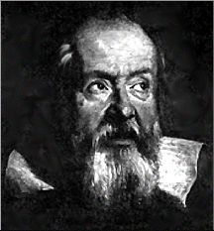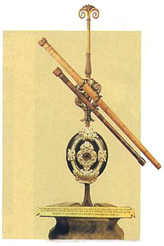
Galileo Galilei (1564-1642)was the first scientist to use a refracting telescope to make important astronomical discoveries. Professor of astronomy at the university of Pisa. A supporter of Copernicus he got in trouble with the church, was convicted of heresy and lived out his life under house arrest.
His major discoveries
Sunspots | 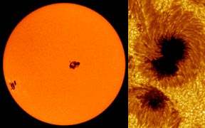 | Galileo was virtually blind in his final years. I wonder why..
The Phases of Venus | 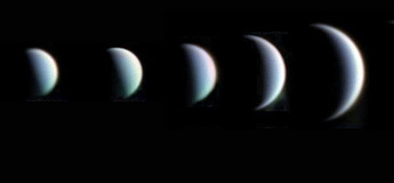 | Why do you think Venus appears different sizes for these different phases?  (Think about where the Earth, Venus and the Sun are)  Important evidence for the heliocentric model.
The relief features of the Moon | 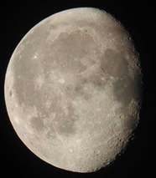 | With his telescope Galileo had fantastic view of the Moon
The principal satellites of Jupiter | 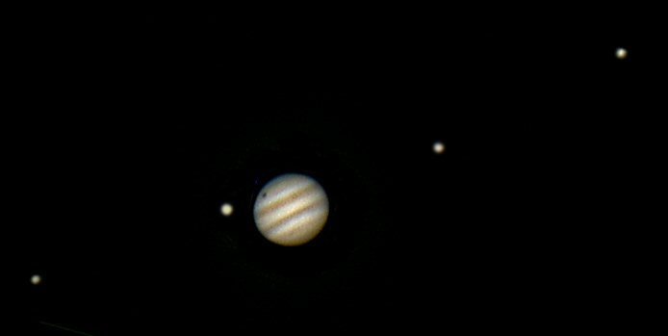 | Galileo realised that these 4 moons orbit Jupiter. Compelling evidence that not everything orbits the Earth. They are now known as the Galilean moons.
The Unusual appearance of Saturn | 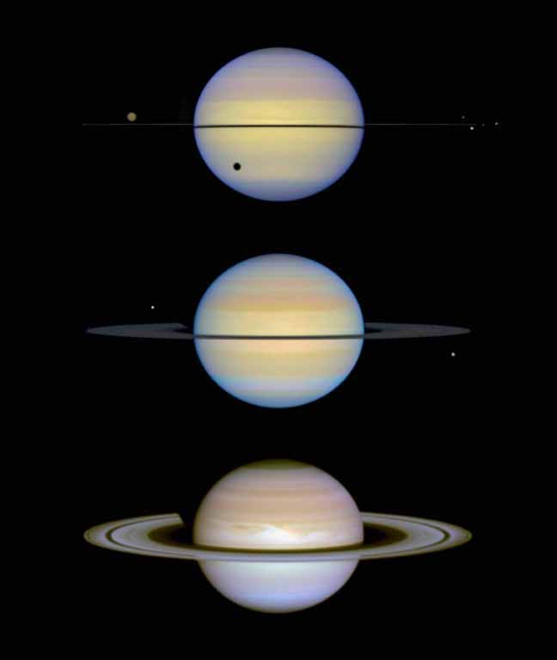 | Galileo saw 2 objects either side of Saturn which disappeared from time to time. What he saw was Saturn's rings from different angles due to its tilt, almost disappearing at times.
Resolving the Milky Way into stars | 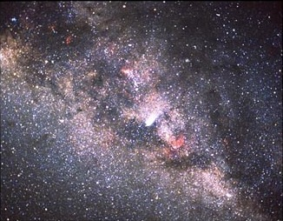 | What appears just a milky cloud is actually billions of stars when seen with a telescope.

