Kepler
describe the contribution of Kepler to our understanding of the Solar System
illustrate Kepler’s second law of planetary motion with the aid of a diagram
demonstrate an understanding of Kepler’s third law relating planetary distances to orbital periods and perform simple calculations using the formula:T² = R³ where T is in years and R is in AU

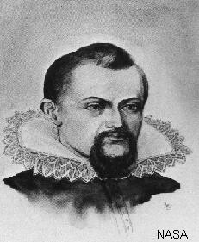
Kepler (1571-1630) is most famous for his 3 laws of planetary motion.

Law 1
The orbit of a planet / comet about the Sun is an ellipse with the Sun at one focus
A circle has a centre. An ellipse has two foci. The further apart the foci are the more eccentric the ellipse is. The Earth's orbit is almost circular. The orbit of comets is very elliptical.
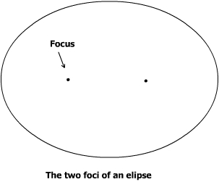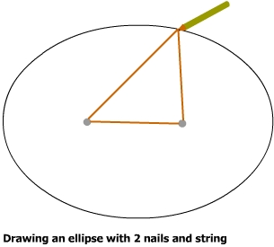

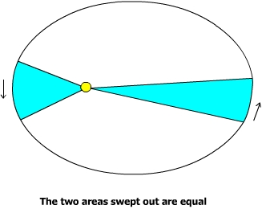
Law 2
A line joining a planet to the Sun sweeps out equal areas in equal time intervals
When comets are closer to the Sun the force of gravity on them is stronger and they travel much quicker. When they are far from the Sun they travel much slower. The area swept out in a certain time is constant.

Law 3
The squares of the periods of the planets are proportional to the cubes of their mean distance from the Sun
Basically if an object is in orbit at a certain radius then it must be travelling at a certain speed so it will take a certain amount of time T to orbit the Sun. Kepler discovered what the relationship between R and T is.
For any planetary system the quantity T²/R³ is constant. For our solar system if we measure T in Earth years and R in AU then T²/R³ must equal 1 as you can see in the table below.
Planet | Period T (yr) | Mean Distance R (AU) | T² | R³ | T²/R³
Mercury | 0.24 | 0.39 | 0.06 | 0.06 | 1
Venus | 0.62 | 0.72 | 0.39 | 0.37 | 1
Earth | 1.00 | 1.00 | 1.00 | 1.00 | 1
Mars | 1.88 | 1.52 | 3.53 | 3.51 | 1
Jupiter | 11.9 | 5.20 | 142 | 141 | 1
Saturn | 29.5 | 9.54 | 870 | 868 | 1
If a new planet were to be discovered at a certain value of R then we could use this relationship to calculate its orbital period.

