Copernicus and Tycho
describe the contribution of Copernicus and Tycho to our understanding of the Solar System
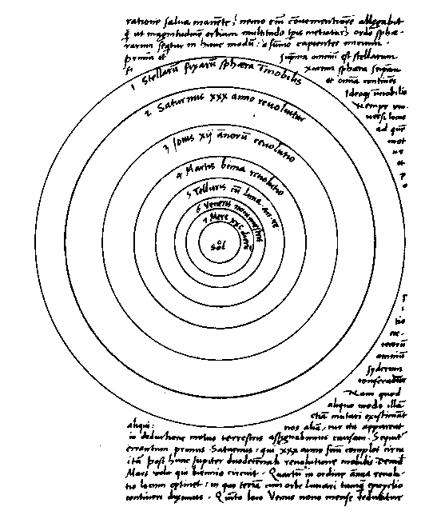
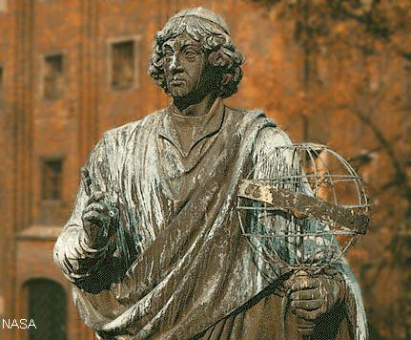

Nicolaus Copernicus (1473-1543) made his observations a hundred years before the invention of the telescope.
In 1530 he produced a book called De Revolutionibus in which he asserted that the earth orbits the Sun once a year. This went against Ptolemiac theory of an Earth centred universe as supported by the church. (Ptolemy was an important Egyptian thinker A.D. 150)
Copernicus didn't live to see the turmoil his work caused. His work forever changed the way man thinks about his place in the cosmos. No longer can he assume that he is at the centre of all things.

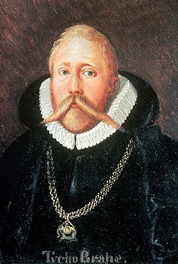
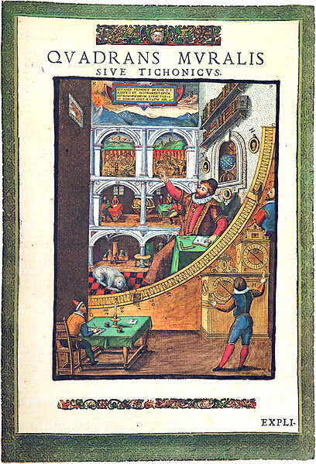
Tycho Brahe (1546-1601) made a huge amount of accurate astronomical and planetary observations. His measurements were accurate enough for Kepler to use in his derivation of his laws of planetary motion.
Tycho did not believe in the heliocentric model. He proposed a system where the Sun orbits the Earth but the other planets orbit the Sun.

