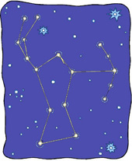

Orion the Hunter: This constellation is a winter constellation, meaning it can only be seen in the winter months. Some constellations can be seen all year round and some constellations are seasonal. As well, some constellations can only be seen from the Northern Hemisphere and some can only be seen from the Southern Hemisphere
Find these constellations:
Aquarius  Aries  Big Dipper  Cancer  Cassiopeia  Centaurus  Cygnus  Draco  Gemini  Indus  Leo  Libra |  | Little Dipper  Lupus  Octans  Orion  Pisces  Pleiades  Sagittarius  Scorpius  Southern Cross  Taurus  Virgo | 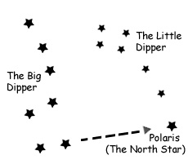  You can find the North Star by using the two pointer stars of the Big Dipper.

Orion the Hunter: This constellation is a winter constellation, meaning it can only be seen in the winter months. Some constellations can be seen all year round and some constellations are seasonal. As well, some constellations can only be seen from the Northern Hemisphere and some can only be seen from the Southern Hemisphere
Find these constellations:
Aquarius  Aries  Big Dipper  Cancer  Cassiopeia  Centaurus  Cygnus  Draco  Gemini  Indus  Leo  Libra |  | Little Dipper  Lupus  Octans  Orion  Pisces  Pleiades  Sagittarius  Scorpius  Southern Cross  Taurus  Virgo | You can find the North Star by using the two pointer stars of the Big Dipper.

