Constellations

- What is the difference between a constellation and a star cluster?
- Name the 4 constellations below.
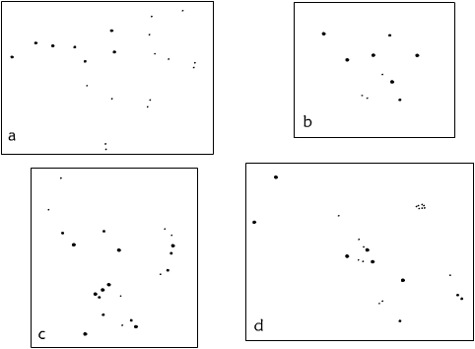
3. Which of these constellations:
a) Has been used for thousands of years to find north?
b) Can be used to find Sirius, the brightest star in the northern hemisphere?
c) Includes the star cluster, The Pleiades?
d) Is one of the twelve constellations of the zodiac?
e) Contains a nebula visible to the naked eye?
f) Is named after the queen of Ethiopia?
4. Name 4 other constellations in the northern hemisphere.

Constellations

  - What is the difference between a constellation and a star cluster?
  - Name the 4 constellations below.
3. Which of these constellations:
a) Has been used for thousands of years to find north?
b) Can be used to find Sirius, the brightest star in the northern hemisphere?
c) Includes the star cluster, The Pleiades?
d) Is one of the twelve constellations of the zodiac?
e) Contains a nebula visible to the naked eye?
f) Is named after the queen of Ethiopia?
4. Name 4 other constellations in the northern hemisphere.

