List the names identified in the diagram below:
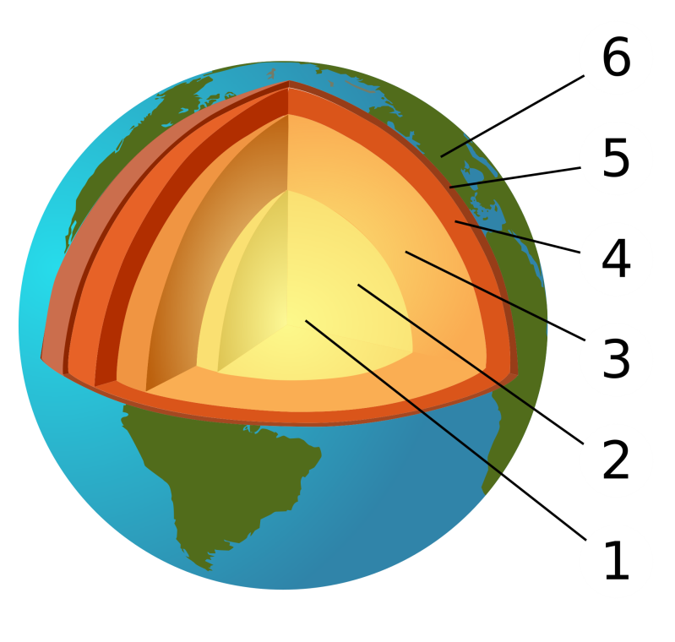

For parts 1 to 5 in the diagram, describe the main features of each part including the thickness, temperature range and what each part is made of:
1
2
3
4
5

